St. Joseph Catholic Church
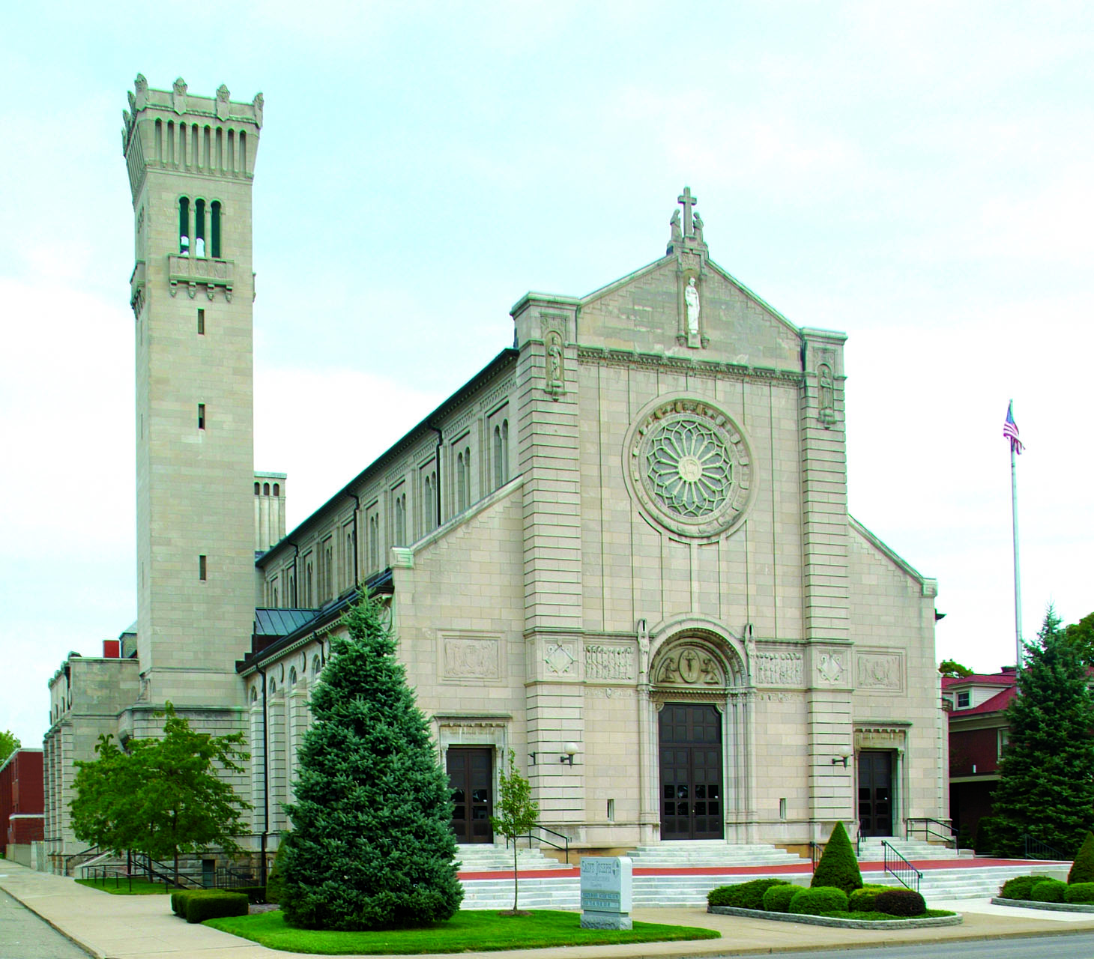
2427 Tuscarawas Street W.
Canton, Ohio 44708
330-453-2526
stjosephcanton@catholicweb.com

Time and Talent Survey

“Sharing the time and talent that God gave me..”

Name __________________________________________
Address________________________________________
Phone (Home)________________(Work)_______________

Non-parish volunteer activities_______________________
______________________________________________

I would like more information about the following ministries or parish organizations:
Note: All ministries are open to men and women. This includes ushers and Mass servers.

___Usher ___Choir
___Greeter ___Handbell Choir
___Adult Mass Server ___Funeral Choir
___Lector ___Communion To Shut-ins
___Eucharistic Min. ___Aultman Hospital Euch.
Minister
___CCD Teacher ___RCIA Faith Sharer
___CCD Aide/Sub ___RCIA Sponsor
___Rosary Altar ___Visiting Shut-Ins
___Men’s Club ___Fish Fry
___Boy Scout ___Men’s Club
___Cub Scout ___Youth Ministry Work
___Bingo Worker ___Tuesday Quilters
___Sacristy Cleaners ___St. Joseph Cupboard
___Cantor at Mass ___COF (Catholic Order of Foresters)



