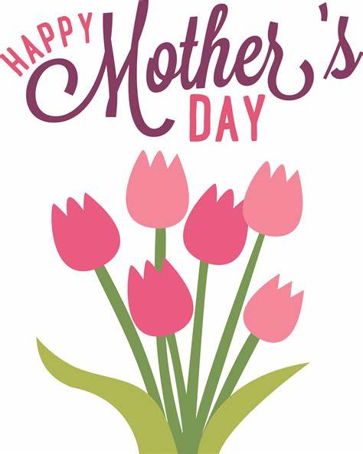
MOTHER’S DAY CANDLES
$4.00 EACH
SUNDAY, MAY 8TH
NAME (S):
____________________________________________
____________________________________________
____________________________________________
AMOUNT ENCLOSED: _____________________

