The Bishops of Ohio Announce the Lifting of the Dispensation from the Obligation to attend Holy Mass
on Sundays and Holy Days of Obligation
May 13, 2021

As we move beyond the worst of the coronavirus pandemic and access to the COVID-19 vaccine has become more widespread, the time has arrived for the good of all the faithful when the general dispensation from the obligation to attend Mass on Sundays and Holy Days of Obligation is no longer necessary.

Together, the Bishops of Ohio have decided that the general obligation to attend Mass on Sundays and Holy Days of Obligation (including the Saturday/Vigil Mass) is to be reinstated (CIC, can. 1247). This will take effect in each of the Dioceses of Ohio the weekend of June 5-6, 2021. As has always been the case, those who have a serious reason are exempt from attending Mass on Sundays and Holy Days of Obligation (Catechism of the Catholic Church, 2181). This includes those who are ill, have significant health risk factors or care for someone who is immuno-compromised or ill, as well as those who have significant fear or anxiety of contracting the coronavirus in a large group of persons. Nevertheless, these persons should observe the Lord’s Day (CIC, can. 1247) and are encouraged to spend time in prayer on Sunday, meditating on the Lord’s passion, death and resurrection; an appropriate way to do this is through viewing a broadcast of the Sunday Mass. Masses that are broadcast through various media are not intended as a substitute nor do they fulfill the obligation for the persons who are able to gather for a Sunday celebration and other Holy Days of Obligation. Instead, they are intended for the sick, home-bound, the imprisoned, etc., who are unable to attend Mass in person. Kindly consult your pastor with any specific questions regarding the obligation to attend Mass on Sundays and Holy Days of Obligation.

The book of Exodus reminds us to keep holy the Sabbath day (Exodus 20: 8-10). As Catholics, we are invited by God to gather together in community, and participate fully in the Sunday Eucharist, which is the “source and summit of the Christian life.” “Participation in the communal celebration of the Sunday Eucharist is a testimony of belonging and of being faithful to Christ and to his Church. The faithful give witness by this to their communion in faith and charity. Together they testify to God’s holiness and their hope of salvation. They strengthen one another under the guidance of the Holy Spirit” (Catechism of the Catholic Church, 2182).

The obligation to attend Mass on Sunday and Holy Days is not something God asks of us out of his own necessity to be worshipped, but rather a gift to the faithful for their spiritual well-being, eternal salvation and formation in our relationship with God and one another. To that end, Saint John Vianney rightly asserts, “There is nothing so great as the Eucharist. If God had something more precious, He would have given it to us.” The Eucharist is the greatest gift Christ left to the Church—the gift of Himself. There is no substitute for Mass celebrated in person.

We are profoundly grateful to our pastors and all of the faithful for their flexibility, fidelity and great generosity in support of the mission of the Church throughout this unprecedented time. As we prepare for the reinstatement of the obligation to attend Mass, we are excited once again to gather together in person without restrictions in our parish churches, most fittingly on the Solemnity of the Most Holy Body and Blood of Christ. As we reflect on our Lord’s goodness and mercy in the midst of the sacrifices made during the coronavirus pandemic, we ask Saint Joseph to intercede for us, that through his fatherly protection and care, we may experience a renewal of faith in the real presence of Christ in the Eucharist.

We welcome you back with great joy and eagerness!

The Most Rev. Dennis M. Schnurr
Archdiocese of Cincinnati
The Most Rev. David J. Bonnar
Diocese of Youngstown
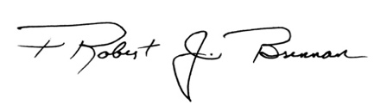
The Most Rev. Robert J. Brennan
Diocese of Columbus

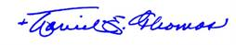
The Most Rev. Daniel E. Thomas
Diocese of Toledo

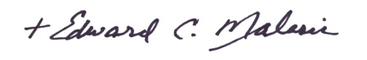
The Most Rev. Edward C. Malesic
Diocese of Cleveland

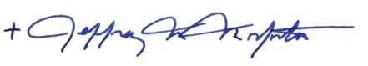
The Most Rev. Jeffrey M. Monforton
Diocese of Steubenville

