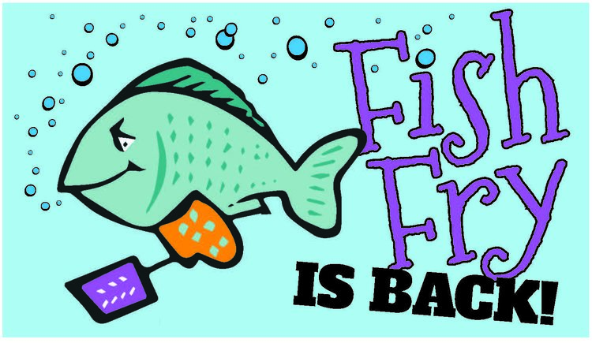

ST. JOSEPH PARISH
LENTEN FISH FRY
FRIDAYS DURING LENT
March 4th Thru April 8th
DRIVE THRU OR CARRY OUT
330-454-2144
4:30 – Order until 6:30PM
St. Joseph School Cafeteria
126 Columbus Ave. NW
Enter from School Parking Lot Door #1 for Carry Out

MENU: 1 pc Fried Fish Dinner $10.00
2 pc Fried Fish Dinner $13.00
3 pc Fried Fish Dinner $16.00
Shrimp Dinner $14.00
1 pc Baked Fish Dinner $16.00

DINNERS INCLUDE:
1 Choice French Fries or Mac & Cheese
1 Choice Applesauce or Cole Slaw
Roll & Butter
Dessert

A LA CART
Fish Sandwich $6.00
Mac & Cheese $5.00
Pierogis (5) $5.00
1 Piece of Fish $5.00

FAMILY DINNER
12 Pieces of Fried Fish $50.00
6 Orders of Fries
1 Quart of Applesauce or coleslaw
6 Rolls & Butter
Dessert

