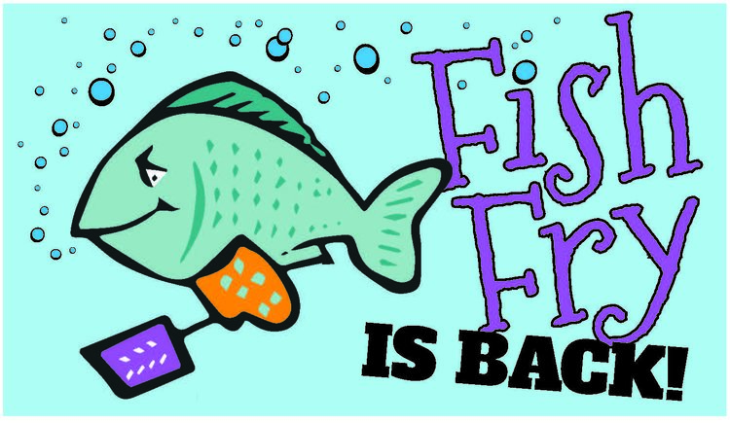

ST. JOSEPH PARISH
LENTEN FISH FRY
FRIDAYS DURNING LENT
February 19th Thru March 26th
DRIVE THRU OR CARRY OUT
330-454-2144
4:30 – Order until 6:30PM
St. Joseph School Cafeteria
126 Columbus Ave. NW
Enter from School Parking Lot Door #1 for Carry Out

MENU: 1 pc Fried Fish Dinner $9.00
3 pc Fried Fish Dinner $13.00
Shrimp Dinner $13.00
1 pc Baked Fish Dinner $13.00

A LA CART
Fish Sandwich $5.50
Mac & Cheese $4.50
Pierogis (5) $5.00

DINNERS INCLUDE:
1 Choice French Fries or Mac & Cheese
1 Choice Applesauce or Cole Slaw
Roll & Butter
Dessert

*Anyone interested in helping with the Fish Fry,
please contact: Bridgett Bialota @ 330.309.3993

