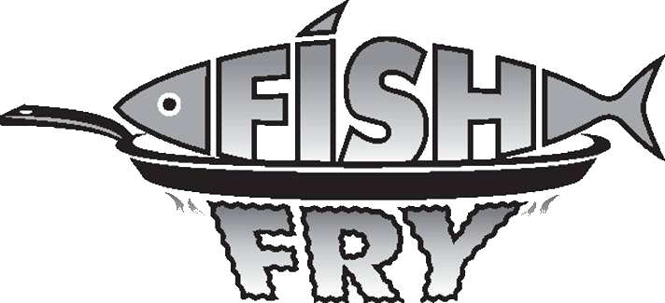

“OCTOBERFISH”
St. Joseph will be having a Fish Fry every Friday in October in the school cafeteria - 4:30-7:00 for
Dine-in/Carry-out

VOLUNTEERS NEEDED!
COME JOIN THE FUN AND HELP WITH THIS CHURCH FUNDRAISER WITH YOUR PARISH FAMILY AND FRIENDS
___________________________________________________________________________

Anyone willing to volunteer please circle the dates available and return to the rectory office in the collection basket or during office hours M-F 8:30-4:30

Thursday night set up: 4:00-7:00PM October 2nd 9th 16th 23rd 30th

Friday early set-up: 2:00-4:00
October 3rd 10th 17th 24th 31st

Friday serve: 4:00-7:00pm
October 3rd 10th 17th 24th 31st

Friday Clean-up: 6:45-?pm
October 3rd 10th 17th 24th 31st

Cake/Pie Bakers October 3rd 10th 17th 24th 31st
(Drop off Thursday Night or Friday)

NAME:_________________________________________________________________

HOME PHONE #:_________________________CELL PHONE#:__________________

EMAIL: _________________________________________________________________________

Any questions please contact Bridgett at 330-309-3993 or the rectory office 330-453-2526

ST. JOSEPH
LENTEN FISH FRY
FRIDAYS DURNING LENT
February 20th, February 27th, March 6th
March 13th, March 20th, & March 27th
DINE IN OR CARRY OUT
330-454-9787
4:30 – 7:30PM
St. Joseph School Cafeteria
126 Columbus Ave. NW
(Enter from School Parking Lot Door #1)

MENU: 1 pc Fried Fish Dinner $5.50
2 pc Fried Fish Dinner $8.00
3 pc Fried Fish Dinner $9.00
Shrimp Dinner $8.00
1 pc Baked Fish Dinner $9.00
Fish Sandwich $3.50
Mac & Cheese Dinner $5.50

DINNERS INCLUDE:
French Fries, Baked Potato or Mac & Cheese
Applesauce or Cole Slaw,
Roll & Butter, Coffee or Tea

~~SOFT DRINKS AND DESSERTS ARE AVAILABLE~~

*Anyone interested in helping with the Fish Fry,
please contact:
Bridgett Bialota @ 330.484.1058

