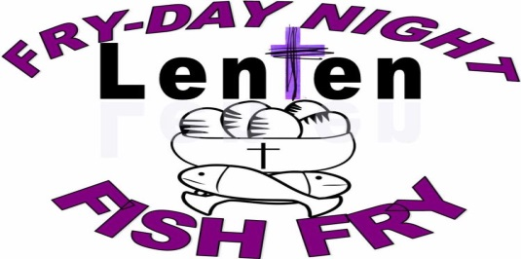

ST. JOSEPH PARISH
LENTEN FISH FRY
FRIDAYS DURNING LENT
March 8th Thru April 12th
DINE IN OR CARRY OUT
330-454-2144
4:30 – 7:30PM
St. Joseph School Cafeteria
126 Columbus Ave. NW
(Enter from School Parking Lot Door #1)

MENU: 1 pc Fried Fish Dinner $7.00
2 pc Fried Fish Dinner $11.00
3 pc Fried Fish Dinner $12.00
Shrimp Dinner $12.00
1 pc Baked Fish Dinner $12.00
Fish Sandwich $4.00
Mac & Cheese Dinner $6.50
Mac & Cheese $3.50
PB&J $1.00
Grilled Cheese $1.50
Fries or Baked Potato $2.00
Pierogi Dinner $7.00
Slice of Cheese Pizza $2.50
Soup of the Week $3.50

DINNERS INCLUDE:
French Fries, Baked Potato or Mac & Cheese
Applesauce or Cole Slaw or Pierogi,
Roll & Butter, Coffee or Tea

~~SOFT DRINKS AND DESSERTS ARE AVAILABLE~~

*Anyone interested in helping with the Fish Fry,
please contact: Bridgett Bialota @ 330.309.3993

